JJAK

488 Capstone Project

Dr. Na

1/26/2020

Use Cases

**Login**

**BASIC COURSE:**

The first time starting the application on their phone, the system displays a Login Page. The user enters their login credentials and click the button “Login” to attempt to login. The computer then searches the database for the proper account information, authenticates the user session, and the user will then enter the game.

**ALTERNATE COURSE:**

**User gives invalid credentials:** The Interface will reject the user with an Error that prompts them to try again up to a preset limit before locking them out. The user is also given the option to add a new account using the “Sign Up” button.

**User has previously logged into the game:** The home page will appear instead of the login page.

**User has tried to login more than five times:** User has an incorrect login attempt five times, resulting in being locked out of their account for a set amount of time.

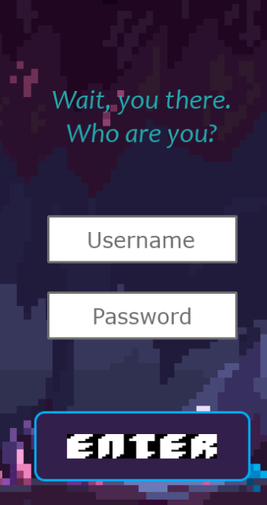

**Create Character**

**BASIC COURSE:**

In the Character Creation page, players can customize a pre-made character with different attributes. The player first types in a name, then selects a class from the drop down menu. They then have 10 attributes to apply to their character in any order. They select the up and down arrows to assign or unassign points. The player hits “Confirm” button to save the settings and enter the game.

**ALTERNATE COURSE:**

**Too many attributes are selected:** The arrows will not allow the user to select less than 0 or more than 10 attributes total. They will be grayed out, along with the “Confirm” button until the right number are selected.

**Name is too long:** After 12 Characters are entered, the text box will not allow any more info to be entered. If the characters are not allowed, the box will blink red.

**Class is not selected:**  The “Confirm” button will be grayed out.

**New Character**

**BASIC COURSE:**

To start a new game, the player hits “New Character” in the main menu; this sends them to the “Create a Character” page. When they enter the details and hit “Confirm”, they are sent to the “Game menu” page. In this menu, they can find a random match by clicking “Find Match” or check their current team by clicking “Team”. In random math, players are automatically assigned to a game that immediately starts.

**ALTERNATE COURSE:**

**User selects Team:** The player is sent to a team page where they can view their current team. They can leave this page by clicking hitting “Quit”.

**User selects Quit:** The player is sent to the home menu.

**Load Game**

**BASIC COURSE:**

To load a saved game, the player hits “Load Game” in the main menu; this sends them to the “Game selection” page. On this page, they are presented with a list of previous games that they can re-enter. After selecting a game, the game starts immediately.

**ALTERNATE COURSE:**

**User has no saved games:** The list of available games is empty and they only have the option to hit the back button.

**Tutorial**

**BASIC COURSE:**

The tutorial begins immediately after the creation of the first character. The game guides the player though the character making process, asking for clicking confirmation between each step. This process is repeated for the character selection, adventure menu, and battle system. Upon completing the tutorial, the user is displayed a congratulations message. After clicking confirm once more, the tutorial terminates and returns the user to the character selection page.

**ALTERNATE COURSE:**

**User selects Quit:** The player is sent to the home menu.